ISCHoF2013MediaReleaseTickets.doc



MEDIA RELEASE
July 26, 2013

ISC Hall of Fame Class of 2013 Induction Breakfast

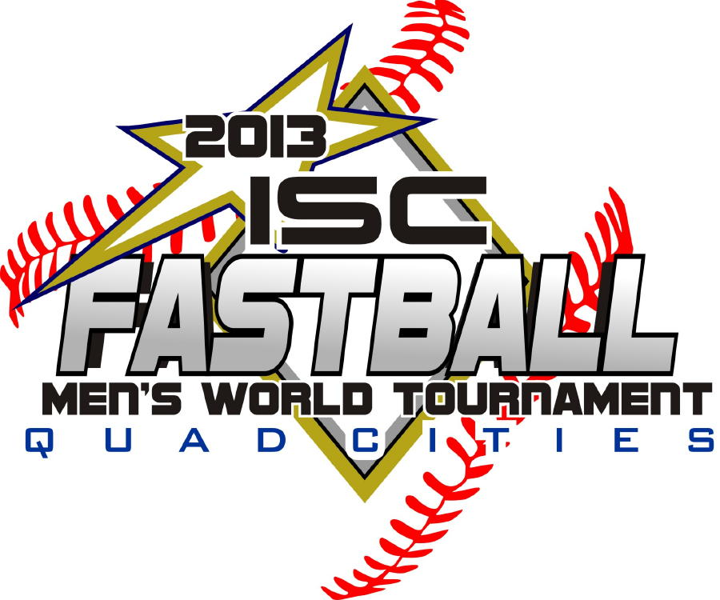

On Sunday morning August 11, the International Softball Congress Hall of Fame will host its annual induction breakfast at the Isle Casino and Hotel in Bettendorf IA.



The Class of 2013 induction will be held as part of the ISC Championships and build on the successes of the previous Hall of Fame celebrations that have been held annually since the initial induction in 1965.

Doors will open at 7:30 am, with breakfast at 8:00 and the program and inductions at 9:15 am. The event will adjourn at 11:30 am, in advance of the Sunday scheduled games at 12:00 noon.

Each and all attendees are required to have a ticket, available as follows:

TICKET SALES

ON-LINE and RESERVED TABLES OF EIGHT
Tickets, $20 each, and/or reserved tables of eight (8) for $150, may be purchased on-line using VISA/MC credit cards by contacting Breakfast Event Chair John Thompson at sstj99@gmail.com or 519-884-4050.

AT ISC REGISTRATION or TEAM MANAGERS MEETING
A limited number of tickets will be available at the ISC Registration on Saturday August 10 between 8:00 am and 4:00 pm and the Team Managers meeting, also at the on Saturday August 10 am.

CLASS OF 2013 INDUCTEES

PLAYERS
David Boys, Decatur IL
Under the tutelage of his father Paul in Maroa IL, David Boys studied the habits of premier softball hitters and tried to imitate their techniques. His own high school and college career was in baseball, but in 1987 he entered the world of fast-pitch, joining the Decatur IL Generals. In 1989 Russ Boice, Decatur IL Pride coach, invited David to join the Pride as a reserve and eventually David earned a starting shortstop role. His stellar play was noted by Gale Kurtz of Sioux City IA Penn Corp where David then suited up for four seasons, winning back-to-back ISC Championships in 1991-92. He repeated the two-peat in 1994-95 with the Decatur IL Pride, and added another ISC title with the Tampa Bay FL Smokers in 1998.

Brian Martie, Bloomington IL
Brian, born and raised in Bloomington IL, played baseball and basketball and ventured into fast-pitch softball in Coffeen IL and was mentored by his father who played in Carbondale IL. Brian joined senior ranks in 1986 with Bloomington IL Hearts and Decatur IL Pride, before closing out his career with half-dozen seasons with Madison WI Farm Tavern, where he was named All-World four of his six times, while winning two ISC titles. His 15 consecutive ISC world tournament appearances resulted in his earning a deserved reputation as a clutch hitter in the big games, and he sported an impressive .300 career batting average.

Steve Schott, Kelso MO
Born in May 1965, Steve followed his fast-pitch playing father A.J. Schott who was a great inspiration and role model. Originally abaseball player, Steve, at age 15, began to also play softball with Ferrell Mobile Homes managed by his father. In the mid-late 1980s, he was invited to play at the elite level and during a twenty year career, suited up with Decatur IL Pride, Sioux City IA NHCD, Green Bay WI All Car Roadrunners, Tampa Bay FL Smokers and Broken Bow NE Travelers. He was an ISC Champion ISC six times, a five-time All-World player, and a three-time member of Team USA.

Four other dedicated softball volunteers are also being recognized in distinctive categories:

FIELD MANAGER
Ron “Doc” Simmons, Broken Bow NE
Born January 27, 1946, Ron “Doc” Simmons became obsessed with softball at age 16 and has sponsored or coached the sport for half-a-century. A graduate of University of Nebraska at Lincoln (UNL), he earned his DDS in 1971 and practices in Broken Bow NE where he formed his own softball club the same year. His teams entered ISC competition in the early 1980s, and since the mid 1990s, his Broken Bow NE Travelers teams have been a perennial championship threat. The Travelers and collaborative teams have been in the ISC title game on 11 occasions, winning the ISC crown six times, and as well have won 21 state ASA titles and two ASA championships.

ISC ADMINISTRATOR
Wayne Fisher, Iowa City IA
Directly out of high school in 1967, Wayne Fisher assembled a softball team that eventually challenged Iowa powerhouse squads. His direct involvement in the late 1970s and early 1980s was instrumental in attracting top-level international pitchers to Cedar Rapids. In 1987 he became an ISC commissioner, the same year his Cedar Rapids IA Teleconnect team won the ISC Championship in Saskatoon SK. From 1996-2009 he served as ISC Developmental (Youth) Vice-President, with his many annual tournaments serving as stepping-stones for players who later excelled at the ISC World Tournaments. He served as ISC Vice-President for the Central Region (2005-2011) and in 2009 was appointed as Iowa ISC Area Tournament commissioner.

UMPIRE
Ron Brinkman, Appleton WI
Ron Brinkman played in the 1979 ISC World Tournament in Bakersfield CA and transitioned to the role of umpire, making his ISC blue debut in 1983 in neighboring Kimberly WI. He traveled to Allentown PA for the 1984 tourney and served as an umpire for 19 years - every year except 1987 (Saskatoon) - and was named the ISC Umpire in Chief in 2002. Family and friends confirm that for Ron, it wasn’t a job, or “work”, but a genuine love for the game. While his family recalls the many weeknight games at Sunset Park, and the weekend tournaments in seemingly endless fast-pitch communities, the annual ISC WT was simply the destination of family vacations each and every summer for two decades.

BOB WELBY MEMORIAL AWARD
Jim Dean, Seattle WA (deceased)
In 1980 Jimmy Dean took his Westside Federal softball club to the ISC World Tournament in Arizona, the inaugural year for the Norwest Area (WA/OR/ID & BC) to send teams to the World event. In 1981, the Norwest Major Fast-pitch League became a recognized ISC travel league. After three years with the Federals, Jimmy joined Bellevue Pay’n Pak and convinced the squad to go to the World Tourney in Kimberly WI in 1985 - they returned as World Champions. The team made appearances for twelve straight years, claiming the championship twice more (1986 as Pay’n Pak and 1990 as Seafirst). Jimmy was also a volunteer with the 1980 ISF World Championships in 1987 in Tacoma WA and served a three-year term as president of the Greater Seattle Fast-pitch Assoc.

The Class of 2013 induction continues the tradition of honoring the finest in ISC participants, building on the successes of the previous celebrations that have been held annually since the initial induction in 1965. It will be held on Sunday August 11 at 8 am at the Isle Casino and Hotel in Bettendorf IA as part of the ISC 2013 Championships in Quad Cities IA/IL

For more information, please contact:

John Thompson, Chair – Breakfast Event Committee
ISC Hall of Fame Class of 2013 Induction
519-884-4050 or by e-mail sstj99@gmail.com



